Online Payments Fraud Detection Using Machine Learning

Project title : Online Payment Fraud Detection Using Machine Learning. This project was developed collaboratively by all team members with Teamwork and coordination played a key role in the successful completion of this project.

Team ID: LTVIP2026TMIDS90440
Team Size : 5
Team Leader : Kakanaboina Pujitha
Team member :Guti Midun Surya Sai
Team member : Jadda Venkata Mohan
Team member : Katakam Brahma Rao
Team member : Anuradala Leelasai

Date of Submission:20/02/2026
Q

Project Description:

This project focuses on developing an Online Payment Fraud Detection System using Machine Learning. The system analyzes transaction data to identify patterns and predict whether a transaction is fraudulent or legitimate.The main goal of this project is to enhance transaction security and reduce financial losses due to fraud.
Various machine learning models like Logistic Regression, Decision Tree, Random Forest, and Support Vector Machine (SVM) are implemented and compared to select the most accurate model. The best-performing model is then integrated into a Flask-based web application, where users can enter transaction details and receive real-time predictions indicating whether a transaction is fraudulent or legitimate. This system helps enhance transaction security and reduce financial losses.
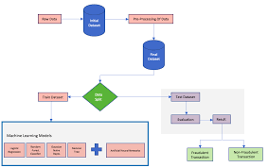
1.Pre-requisites of the Project:
To complete this project, we have must the following software’s concepts and packages.
- Visual Studio Code (VS Code):
- Refer the link below to download the vs code.
https://code.visualstudio.com/
- Packages:
Open vs code and install these
- Type “pip install numpy” and click run button
- Type “pip install pandas” and click run button
- Type “pip install matplotlib” and click run button
- Type “pip install seaborn” and click run button
- Type “pip install scikit-learn” and click run button
- Type “pip install flask” and click run button
- Type “pip install joblib” and click run button
2.ML Concepts:
Supervised learning

Supervised learning trains a model using labeled data. In this project, transactions are labeled as fraud or normal.

Link: https://www.geeksforgeeks.org/supervised-machine-learning/
Data Preprocessing
Cleaning and preparing raw data before training the model. Includes:
- Removing missing values
- Normalization
- Feature scaling
- Encoding

Link:
https://www.geeksforgeeks.org/data-preprocessing-in-machine-learning/
Feature Selection:
Selecting the most important features that improve prediction accuracy.
Link:
https://www.geeksforgeeks.org/feature-selection-techniques-in-machine-learning/

Logistic Regression
A classification algorithm used to predict binary outcomes (fraud / not fraud).
Link:
https://www.geeksforgeeks.org/understanding-logistic-regression/

Decision Tree
A tree-based model that makes predictions using if–else rules.
Link:
https://www.geeksforgeeks.org/decision-tree-introduction-example/

Random Forest
An ensemble method that combines multiple decision trees for better accuracy and reduced overfitting.
Link:
https://www.geeksforgeeks.org/random-forest-algorithm-in-machine-learning/

Support Vector Machine (SVM)
A powerful classifier that separates classes using an optimal decision boundary.
Link:
https://www.geeksforgeeks.org/support-vector-machine-algorithm/

Model Training & Testing
Splitting data into training and testing sets to evaluate performance.
Link:
https://www.geeksforgeeks.org/splitting-data-for-machine-learning-model/

Model Evaluation Metrics
Used to measure model performance:
- Accuracy
- Precision
- Recall
- F1-score
- Confusion Matrix
Link:
https://www.geeksforgeeks.org/confusion-matrix-machine-learning/
Project Flow:

online-payment-fraud-detection/
│
├── app.py
├── model_training.ipynb
├── fraud_model.pkl
├── scaler.pkl
├── requirements.txt
├── README.md
│
├── dataset/
│ └── transactions.csv
│
├── templates/
│ ├── home.html
│ └── submit.html
│
├── static/
│ ├── style.css
│ └── images/
│
└── notebooks/
└── data_analysis.ipynb
Correlation Matrix /Heatmap:
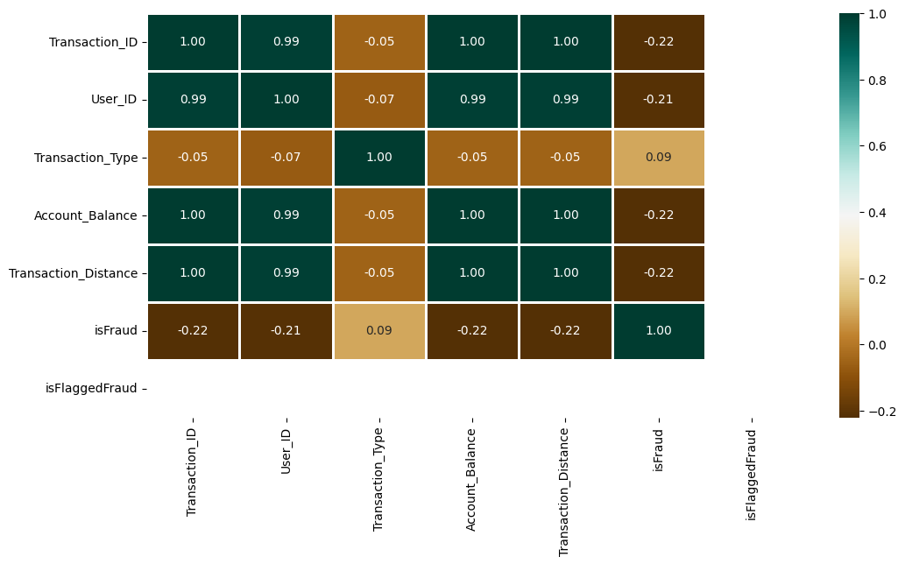
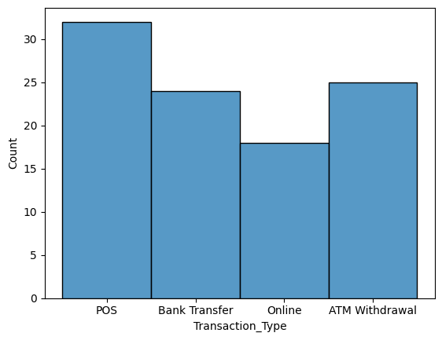
Histplot
Random Forest Classifier :
The second classifier was Random Forest and gave the accuracy of 87 percent, precision of 96.3 and AUC of 99 percent. The confusion matrix of the same is shown below.

precision recall f1-score support

0 1.00 1.00 1.00 20

accuracy 1.00 20
macro avg 1.00 1.00 1.00 20
weighted avg 1.00 1.00 1.00 20
Transaction type and account balance is fraud or not.
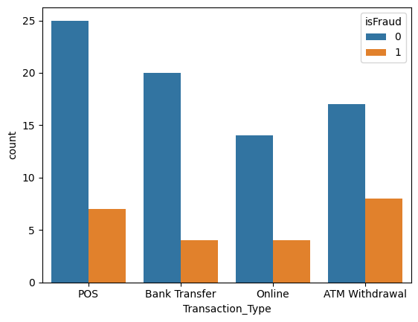
The boxplot shows based on the account balance is fraud or not looks like.
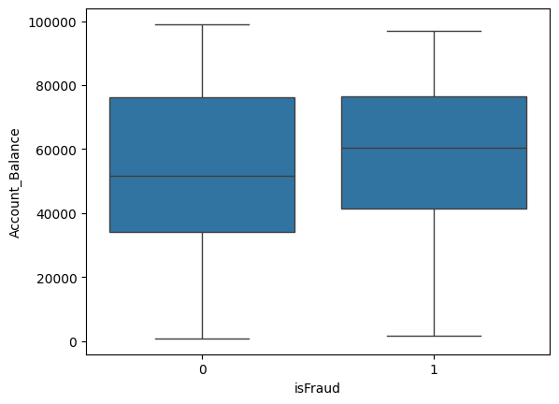

Overall Project Conclusion
The Online Payment Fraud Detection System using Machine Learning was successfully designed and implemented to identify fraudulent transactions accurately and efficiently. The project involved data preprocessing, feature selection, model training, testing, and evaluation using various machine learning algorithms such as Logistic Regression, Decision Tree, Random Forest, and Support Vector Machine (SVM).
Among the tested models, the best-performing algorithm was selected and deployed using a Flask-based web application, enabling real-time fraud prediction through a user-friendly interface. The system effectively analyzes transaction details and classifies them as fraudulent or legitimate, helping financial institutions and users reduce financial risks.
Overall, this project demonstrates the practical application of machine learning in enhancing cybersecurity and financial transaction safety. It also provides a scalable foundation for future improvements, including real-time monitoring, deep learning integration, and large-scale deployment in real-world banking systems.

